LAB INDEX

NAME: Vivek Kumar SUBJECTNAME: Project Based Learning in Java Lab

UID: 21BCS8129 SUBJECTCODE: 20CSP-314

SECTION: WM-20BCS-616/A

|  |  |  |  |  |  |  |  |
| --- | --- | --- | --- | --- | --- | --- | --- |
| **Sr.No** | **Program** | **Date** | **Evaluation** | | | | **Sign** |
| **LW**  **(12)** | **VV**  **(10)** | **FW**  **(8)** | **Total**  **(30)** |
| 1 | Create an application to save the employee information using arrays. | 09-08-2022 |  |  |  |  |  |
| 2 | Design and implement a simple inventory control system for a small video rentalstore. | 23-08-2022 |  |  |  |  |  |
| 3 | Create a application to calculate interest for FDs, RDs based on certain conditions using inheritance. | 02-09-2022 |  |  |  |  |  |
| 4 | Create a program to show the usage of Sets of Collection interface. | 27-09-2022 |  |  |  |  |  |
| 5 | Create a program to set view of Keys from Java Hashtable. | 27-09-2022 |  |  |  |  |  |
| 6 | Write a Program to perform the basic operations like insert, delete, display and search in list. List contains String object items where these operations are to be performed. |  |  |  |  |  |  |
| 7 | Create a menu based Java application with the following options.1.Add an Employee2.Display All3.Exit If option 1 is selected, the application should gather details of the employee like employee name, employee id, designation and salary and store it in a file. If option 2 is selected, the application should display all the employee details. If option 3 is selected the application should exit. |  |  |  |  |  |  |
| 8 | Create a palindrome creator application for making a longest possible palindrome out of given input string. |  |  |  |  |  |  |
| 9 | Create a Servlet/ application with a facility to print any message on web browser. |  |  |  |  |  |  |
| 10 | Create JSP application for addition, multiplication and division. |  |  |  |  |  |  |

## CHANDIGARH UNIVERSITY

## UNIVERSITY INSTITUTE OF NGINEERING

**DEPARTMENT OF COMPUTER SCIENCE & ENGINEERING**



|  |  |
| --- | --- |
| **Submitted By: Submitted To:**  Vivek Kumar(21BCS8129) Neeru Sharma(E12950) | |
| **Subject Name** | Project Based Learning in Java Lab |
| **Subject Code** | 20CSP-321 |
| **Branch** | Computer Science and Engineering |
| **Semester** | 5th |

**Experiment - 5**

**Student Name: Vivek Kumar UID: 21BCS8129**

**Branch: BE-CSE(LEET) Section/Group:20BCS-WM-616/A**

**Semester: 5th Date of Performance: 27/09/2022**

**Subject Name:** **Project Based Learning in Java Lab Subject Code: 20CSP-321**

**1. Aim/Overview of the practical:**

Create a program to set view of Keys from Java Hashtable.

**2. Task to be done/ Which logistics used:**

Write the program to create an application to perform operation on Hashtable.

**3. Software Requirements (For programming-based labs):**

* JDK-8 or any
* Eclipse-IDE for Java

**4. Steps for experiment/practical/Code:**

package unit2;

import java.util.Enumeration;

import java.util.Hashtable;

public class WorkSheet5 {

public static void main(String[] args) {

// TODO Auto-generated method stub

Hashtable<Integer, String> ht = new Hashtable<>();

ht.put(1, "Vivek");

ht.put(2, "Abhi");

ht.put(3, "Amar");

ht.put(4, "Punya");

ht.put(5, "Vikash");

ht.put(6, "Ruh");

Enumeration<Integer> keys = ht.keys();

Enumeration<String> values = ht.elements();

while(keys.hasMoreElements() && values.hasMoreElements()){

System.out.println("Key: "+keys.nextElement()+"\tValue: "+values.nextElement());

}

}

}

**5. Observations/Discussions/ Complexity Analysis:**

Here we have created the Hashtable and Enumeration and Data inserted to Hashtable with the key pairs, performed display operation.

**6. Result/Output/Writing Summary:**

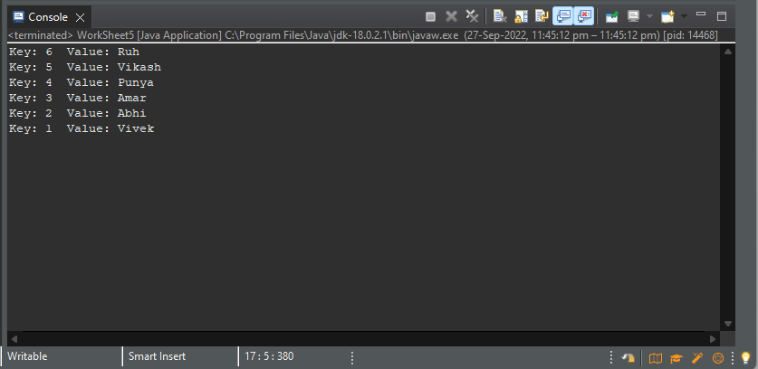

**Learning outcomes (What I have learnt):**

**1.** Learnt How to create the Hashtable and insert the values to it.

**2.** Hashtable manipulation concept understood.

**3.** Learnt the concept of Enumeration.

**4.** Learnt concept of while and Hashtable iteration.

**5.** Understood the concept of AND operator ‘&&’.

**Evaluation Grid (To be created per the faculty's SOP and Assessment guidelines):**

|  |  |  |  |
| --- | --- | --- | --- |
| Sr. No. | Parameters | Marks Obtained | Maximum Marks |
| 1. | Worksheet completion including writing learning objectives/Outcomes.  (To be submitted at the end of the day). |  |  |
| 2. | Post-Lab Quiz Result. |  |  |
| 3. | Student Engagement in  Simulation/Demonstration/Performance and Controls/Pre-Lab Questions. |  |  |
|  | Signature of Faculty (with Date): | Total Marks Obtained: |  |